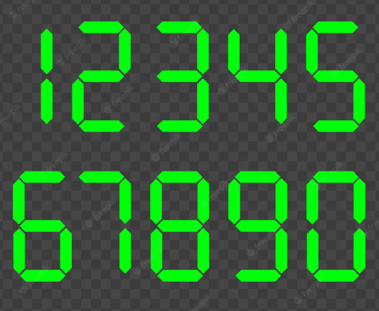

| DC | a | b | c | d | s |
| --- | --- | --- | --- | --- | --- |
| 0 | 0 | 0 | 0 | 0 | 1 |
| 1 | 0 | 0 | 0 | 1 | 1 |
| 2 | 0 | 0 | 1 | 0 | 1 |
| 3 | 0 | 0 | 1 | 1 | 1 |
| 4 | 0 | 1 | 0 | 0 | 1 |
| 5 | 0 | 1 | 0 | 1 | 0 |
| 6 | 0 | 1 | 1 | 0 | 0 |
| 7 | 0 | 1 | 1 | 1 | 1 |
| 8 | 1 | 0 | 0 | 0 | 1 |
| 9 | 1 | 0 | 0 | 1 | 1 |
| 10 | 1 | 0 | 1 | 0 | 1 |
| 11 | 1 | 0 | 1 | 1 | 1 |
| 12 | 1 | 1 | 0 | 0 | 1 |
| 13 | 1 | 1 | 0 | 1 | 1 |
| 14 | 1 | 1 | 1 | 0 | 1 |
| 15 | 1 | 1 | 1 | 1 | 0 |

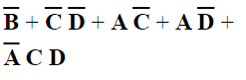

| DB | a | b | c | d | s |
| --- | --- | --- | --- | --- | --- |
| 0 | 0 | 0 | 0 | 0 | 1 |
| 1 | 0 | 0 | 0 | 1 | 1 |
| 2 | 0 | 0 | 1 | 0 | 0 |
| 3 | 0 | 0 | 1 | 1 | 1 |
| 4 | 0 | 1 | 0 | 0 | 1 |
| 5 | 0 | 1 | 0 | 1 | 1 |
| 6 | 0 | 1 | 1 | 0 | 1 |
| 7 | 0 | 1 | 1 | 1 | 1 |
| 8 | 1 | 0 | 0 | 0 | 1 |
| 9 | 1 | 0 | 0 | 1 | 1 |
| 10 | 1 | 0 | 1 | 0 | 1 |
| 11 | 1 | 0 | 1 | 1 | 1 |
| 12 | 1 | 1 | 0 | 0 | 0 |
| 13 | 1 | 1 | 0 | 1 | 1 |
| 14 | 1 | 1 | 1 | 0 | 1 |
| 15 | 1 | 1 | 1 | 1 | 1 |



| EC | a | b | c | d | s |
| --- | --- | --- | --- | --- | --- |
| 0 | 0 | 0 | 0 | 0 | 1 |
| 1 | 0 | 0 | 0 | 1 | 0 |
| 2 | 0 | 0 | 1 | 0 | 0 |
| 3 | 0 | 0 | 1 | 1 | 0 |
| 4 | 0 | 1 | 0 | 0 | 1 |
| 5 | 0 | 1 | 0 | 1 | 1 |
| 6 | 0 | 1 | 1 | 0 | 1 |
| 7 | 0 | 1 | 1 | 1 | 0 |
| 8 | 1 | 0 | 0 | 0 | 1 |
| 9 | 1 | 0 | 0 | 1 | 1 |
| 10 | 1 | 0 | 1 | 0 | 1 |
| 11 | 1 | 0 | 1 | 1 | 0 |
| 12 | 1 | 1 | 0 | 0 | 0 |
| 13 | 1 | 1 | 0 | 1 | 0 |
| 14 | 1 | 1 | 1 | 0 | 1 |
| 15 | 1 | 1 | 1 | 1 | 1 |

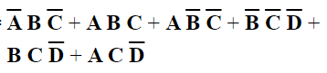

| EB | a | b | c | d | s |
| --- | --- | --- | --- | --- | --- |
| 0 | 0 | 0 | 0 | 0 | 1 |
| 1 | 0 | 0 | 0 | 1 | 0 |
| 2 | 0 | 0 | 1 | 0 | 1 |
| 3 | 0 | 0 | 1 | 1 | 0 |
| 4 | 0 | 1 | 0 | 0 | 0 |
| 5 | 0 | 1 | 0 | 1 | 0 |
| 6 | 0 | 1 | 1 | 0 | 1 |
| 7 | 0 | 1 | 1 | 1 | 0 |
| 8 | 1 | 0 | 0 | 0 | 1 |
| 9 | 1 | 0 | 0 | 1 | 0 |
| 10 | 1 | 0 | 1 | 0 | 1 |
| 11 | 1 | 0 | 1 | 1 | 0 |
| 12 | 1 | 1 | 0 | 0 | 1 |
| 13 | 1 | 1 | 0 | 1 | 0 |
| 14 | 1 | 1 | 1 | 0 | 0 |
| 15 | 1 | 1 | 1 | 1 | 0 |



| MC | a | b | c | d | s |
| --- | --- | --- | --- | --- | --- |
| 0 | 0 | 0 | 0 | 0 | 1 |
| 1 | 0 | 0 | 0 | 1 | 0 |
| 2 | 0 | 0 | 1 | 0 | 1 |
| 3 | 0 | 0 | 1 | 1 | 1 |
| 4 | 0 | 1 | 0 | 0 | 0 |
| 5 | 0 | 1 | 0 | 1 | 1 |
| 6 | 0 | 1 | 1 | 0 | 1 |
| 7 | 0 | 1 | 1 | 1 | 1 |
| 8 | 1 | 0 | 0 | 0 | 1 |
| 9 | 1 | 0 | 0 | 1 | 1 |
| 10 | 1 | 0 | 1 | 0 | 1 |
| 11 | 1 | 0 | 1 | 1 | 0 |
| 12 | 1 | 1 | 0 | 0 | 1 |
| 13 | 1 | 1 | 0 | 1 | 1 |
| 14 | 1 | 1 | 1 | 0 | 0 |
| 15 | 1 | 1 | 1 | 1 | 1 |



| MM | a | b | c | d | s |
| --- | --- | --- | --- | --- | --- |
| 0 | 0 | 0 | 0 | 0 | 0 |
| 1 | 0 | 0 | 0 | 1 | 0 |
| 2 | 0 | 0 | 1 | 0 | 1 |
| 3 | 0 | 0 | 1 | 1 | 1 |
| 4 | 0 | 1 | 0 | 0 | 1 |
| 5 | 0 | 1 | 0 | 1 | 1 |
| 6 | 0 | 1 | 1 | 0 | 1 |
| 7 | 0 | 1 | 1 | 1 | 0 |
| 8 | 1 | 0 | 0 | 0 | 1 |
| 9 | 1 | 0 | 0 | 1 | 1 |
| 10 | 1 | 0 | 1 | 0 | 0 |
| 11 | 1 | 0 | 1 | 1 | 0 |
| 12 | 1 | 1 | 0 | 0 | 1 |
| 13 | 1 | 1 | 0 | 1 | 1 |
| 14 | 1 | 1 | 1 | 0 | 1 |
| 15 | 1 | 1 | 1 | 1 | 1 |

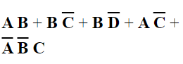

| MB | a | b | c | d | s |
| --- | --- | --- | --- | --- | --- |
| 0 | 0 | 0 | 0 | 0 | 1 |
| 1 | 0 | 0 | 0 | 1 | 0 |
| 2 | 0 | 0 | 1 | 0 | 1 |
| 3 | 0 | 0 | 1 | 1 | 1 |
| 4 | 0 | 1 | 0 | 0 | 0 |
| 5 | 0 | 1 | 0 | 1 | 1 |
| 6 | 0 | 1 | 1 | 0 | 1 |
| 7 | 0 | 1 | 1 | 1 | 0 |
| 8 | 1 | 0 | 0 | 0 | 1 |
| 9 | 1 | 0 | 0 | 1 | 1 |
| 10 | 1 | 0 | 1 | 0 | 1 |
| 11 | 1 | 0 | 1 | 1 | 0 |
| 12 | 1 | 1 | 0 | 0 | 1 |
| 13 | 1 | 1 | 0 | 1 | 1 |
| 14 | 1 | 1 | 1 | 0 | 0 |
| 15 | 1 | 1 | 1 | 1 | 1 |

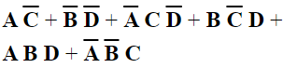

| Dezenas | a | b | c | d | s |
| --- | --- | --- | --- | --- | --- |
| 0 | 0 | 0 | 0 | 0 | 0 |
| 1 | 0 | 0 | 0 | 1 | 0 |
| 2 | 0 | 0 | 1 | 0 | 0 |
| 3 | 0 | 0 | 1 | 1 | 0 |
| 4 | 0 | 1 | 0 | 0 | 0 |
| 5 | 0 | 1 | 0 | 1 | 0 |
| 6 | 0 | 1 | 1 | 0 | 0 |
| 7 | 0 | 1 | 1 | 1 | 0 |
| 8 | 1 | 0 | 0 | 0 | 0 |
| 9 | 1 | 0 | 0 | 1 | 0 |
| 10 | 1 | 0 | 1 | 0 | 1 |
| 11 | 1 | 0 | 1 | 1 | 1 |
| 12 | 1 | 1 | 0 | 0 | 1 |
| 13 | 1 | 1 | 0 | 1 | 1 |
| 14 | 1 | 1 | 1 | 0 | 1 |
| 15 | 1 | 1 | 1 | 1 | 1 |



| Soma | bit1 | bit2 | Vem 1 | Saída | Vai 1 |
| --- | --- | --- | --- | --- | --- |
| 0 | 0 | 0 | 0 | 0 | 0 |
| 1 | 0 | 0 | 1 | 1 | 0 |
| 2 | 0 | 1 | 0 | 1 | 0 |
| 3 | 0 | 1 | 1 | 0 | 1 |
| 4 | 1 | 0 | 0 | 1 | 0 |
| 5 | 1 | 0 | 1 | 0 | 1 |
| 6 | 1 | 1 | 0 | 0 | 1 |
| 7 | 1 | 1 | 1 | 1 | 1 |

